**Research Paper:** **Sequence to Sequence Learning with Neural Networks**

The core idea of Seq2Seq learning involves **mapping variable-length input sequences** to variable-length output sequences using two **Long Short-Term Memory (LSTM)** networks: **“one for encoding the input sequence”** and **“another for decoding the target sequence”**. This method achieves state-of-the-art results for machine translation and other sequential tasks.

The paper introduces a novel approach to handling **sequence-to-sequence (Seq2Seq)** problems using **Recurrent Neural Networks (RNNs)**, specifically **Long Short-Term Memory (LSTM)** networks. This method was primarily developed to address tasks like **machine translation**, but it has broader implications for other tasks involving sequences.

* **Key Contributes:** 
  + **Generalized Sequence Learning:** The Seq2Seq model can handle tasks with variable-length sequences, which previously posed challenges for traditional deep neural networks (DNNs).
  + **LSTM Networks:** The authors use **LSTM networks** to handle long-term dependencies in sequences, which addresses the vanishing gradient problem associated with Recurrent Neural Networks (RNNs).
  + **English-to-French Translation:** On the **WMT'14 English-to-French translation task**, the Seq2Seq model achieves a BLEU score of 34.8, outperforming traditional **phrase-based Statistical Machine Translation (SMT)** systems, which score 33.3.
  + **Word Reversal Trick:** They found that **reversing the order of words** in source sentences significantly improved model performance by introducing short-term dependencies that simplified optimization.
* **Key Components of the Paper:**

1. **The Problem of Sequence Learning:**

The paper starts by identifying a gap in traditional neural networks' ability to handle sequences. Earlier **Deep Neural Networks (DNNs)** could only work on tasks where inputs and outputs had fixed dimensionalities, such as image classification. However, many real-world problems (e.g., **machine translation, speech recognition**) involve variable-length sequences, making fixed-dimensional models unsuitable.

For example, in **Machine Translation:**

* The input might be an English sentence: “I am a student.”
* The output could be a French sentence: “Je suis un étudiant.”

Since the lengths of the sentences can differ, and each sequence has a varying structure, typical DNNs can't directly map such inputs to outputs.

The authors propose a **Seq2Seq** model that uses two RNNs:

* One to **encode** the input sequence into a vector.
* Another to **decode** this vector into the target sequence.

1. **Long Short-Term Memory (LSTM) Architecture:**

The paper highlights the use of **LSTM** networks to handle **long-range dependencies** in sequences. Traditional **RNNs** suffer from the **vanishing gradient problem**, where the network struggles to learn long-term dependencies due to diminishing gradients during backpropagation.

LSTMs overcome this by introducing **memory cells** that can retain information over long periods, allowing the model to learn relationships between distant elements in a sequence (e.g., words at the beginning and end of a sentence). This is crucial for tasks like translation, where words at the start of a sentence influence the translation of words toward the end.

The authors explain that LSTMs are particularly well-suited for **sequence-to-sequence tasks** because they can learn from **temporal dependencies**, which are critical in sequences where order matters.

1. **Seq2Seq Model (Encoder-Decoder Architecture):**

The core of the model is the **Encoder-Decoder** architecture, consisting of two LSTMs:

* **Encoder:** Reads the input sequence (e.g., an English sentence) one token at a time and transforms it into a **context vector** (a fixed-length vector representation of the entire input sequence).
  + **Example:** For the sentence "I am a student", the encoder converts the sequence of words into a single, fixed-size context vector that encodes the meaning of the entire sentence.
* **Decoder:** Takes the context vector produced by the encoder and generates the output sequence (e.g., the French translation) one word at a time.
  + **Example:** The decoder takes the context vector and generates the sentence "Je suis un étudiant" by predicting each word in sequence based on the context vector and the previously predicted words.

This architecture is flexible and can handle sequences of different lengths.

1. **Training the Sequence Model:**

The Seq2Seq model is trained to **maximize the probability** of the correct output sequence given the input sequence. The objective function for training is the **conditional probability** of the output sequence, p(y1, ….., yT | x1, ….., xT ), where:

* x1, ….., xT is the input sequence (e.g., an English sentence).
* y1, ….., yT is the output sequence (e.g., the translated French sentence).

The model uses **Stochastic Gradient Descent (SGD)** to update its parameters and improve translation quality over time.

1. **Word Reversal Trick:**

One of the notable innovations in this paper is the **word reversal trick**. The authors found that reversing the order of words in the source sentence (but not in the target sentence) improves the model’s performance. This technique introduces **short-term dependencies** between the input and output, making the optimization problem easier for the LSTM to solve.

* **Example:** Instead of feeding the sentence "I am a student" into the encoder, they reverse it to "student a am I", and then use the same process to generate the output. **This allows the first word of the target sentence to be influenced by the last word of the input sentence, making training more effective**.

The result of reversing the input sequence is a reduction in **test perplexity** (a measure of how well a probabilistic model predicts a sample) and an increase in translation quality, as measured by the **BLEU score.**

1. **Evaluation on Machine Translation Task:**

The model was tested on the **WMT’14 English to French** machine translation task, using an ensemble of deep LSTM networks. The authors used a **beam search decoder** to generate the translations.

* The model achieved a **BLEU score of 34.8**, outperforming traditional phrase-based **Statistical Machine Translation (SMT)** systems, which achieved a score of 33.3.
* They also experimented with **resorting hypotheses** generated by SMT systems using the LSTM model, which further improved the BLEU score to **36.5**, close to the state-of-the-art results of **37.0** at that time.

This performance demonstrates the model’s ability to capture the meaning of sentences and generate accurate translations, even for long and complex sentences.

1. **Strengths and Limitation:**

**Strengths:**

* **Generalization:** The Seq2Seq model can be applied to any sequence-based problem, not just machine translation. It has since been applied to tasks like **speech recognition**, **summarization**, **question answering**, and more.
* **Handling Long Sequences:** By using LSTMs, the model can successfully learn long-term dependencies, a common challenge in tasks like translation.

**Limitations:**

* **Context Vector Bottleneck:** The entire input sequence is compressed into a **single fixed-length vector**. For very long sequences, this can become a bottleneck, as all the information must fit into a single vector. Later work introduced **attention mechanisms** to overcome this by allowing the model to focus on different parts of the input sequence at different times.
* **Encoder-Decoder Architecture:**

The **Seq2Seq** model consists of two main components: an **Encoder** and a **Decoder** both implemented using **LSTMs**. Let's explore these components with the help of an example.

1. **Encoder:**

* The **encoder** reads the input sequence (e.g., a sentence in English), one element (word) at a time, and produces a **fixed-size context vector.**
* This context vector is a compressed representation of the entire input sequence and is generated from the hidden states of the LSTM at each timestep.
* **Encoder Process:**
* The encoder reads each word of the input sentence ("I", "am", "a", "student") sequentially.
* At each step, the encoder's LSTM updates its hidden state and processes the input, ultimately compressing the entire sentence into a **context vector.**
* The final hidden state of the encoder (context vector) is a summary of the input sentence.

1. **Decoder:**

* The **decoder** takes the context vector from the encoder as input and generates the output sequence (e.g., the translated sentence in French), one word at a time.
* At each step, the decoder predicts the next word in the output sequence based on the previous words and the context vector.
* **Decoder Process:**
* The decoder takes the context vector and generates the output sentence ("Je suis un étudiant").
* At each decoding step, **the decoder predicts the next word based on the context vector and previously generated words**.
* For instance, it first predicts "Je", then "suis", and so on until it produces the complete sentence "Je suis un étudiant".

The **Seq2Seq model with LSTMs** introduced in this paper represents a major breakthrough in handling **sequence-to-sequence problems** like machine translation. The use of **Encoder-Decoder** architecture allows the model to map sequences of arbitrary length to one another, overcoming the limitations of traditional DNNs.

The model achieved state-of-the-art results in machine translation and laid the foundation for future advancements in **neural machine translation**, **speech recognition**, and other sequential tasks. The introduction of techniques like **word reversal** and the innovative use of **LSTMs** for handling long-term dependencies made it possible for this model to handle complex tasks with impressive accuracy.

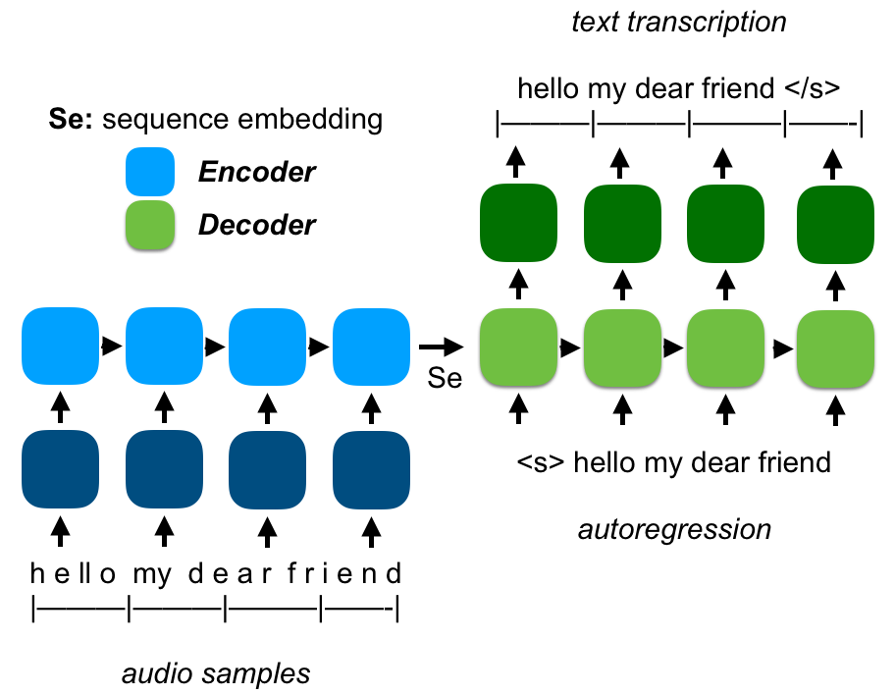

**Research Paper:** **Neural Machine Translation by Jointly Learning to Align and Translate**

The research paper **"Neural Machine Translation by Jointly Learning to Align and Translate"** by Dzmitry Bahdanau, KyungHyun Cho, and Yoshua Bengio introduces a significant improvement to neural machine translation (NMT) through the integration of an **attention mechanism**. This paper presents a solution to the limitations of earlier encoder-decoder models, especially for handling long sentences.

* **Key Contributions of the Paper:**

1. **Addressing the Fixed-Length Context Bottleneck:** The authors identified that traditional encoder-decoder models, such as those used in earlier **NMT** systems, compress the entire input sentence into a **fixed-length vector**. This approach works well for short sentences but struggles with long sentences, leading to performance degradation.
2. **Introduction of Attention Mechanism:** To overcome the fixed-length vector limitation, the paper introduces an **attention mechanism** that allows the model **to focus on different parts of the input sentence as it generates each word of the output**. This is key to improving translation quality, particularly for longer sentences.
3. **Learning to Align and Translate Simultaneously:** The attention mechanism effectively aligns parts of the source sentence with the corresponding parts of the target sentence during translation. This alignment is **soft** rather than **hard**, meaning that it assigns varying degrees of attention to different words in the source sentence, rather than selecting just one word.

* **Neural Machine Translation Overview (NMT):**

The goal of machine translation is to find a target sentence **‘y’** that maximizes the conditional probability **‘p(x|y)’**, where **‘x’** is the source sentence. **NMT** models are designed to learn this probability distribution from large parallel corpora.

**In traditional encoder-decoder models:**

* The **encoder** reads the source sentence and compresses it into a fixed-length vector.
* The **decoder** uses this vector to generate the target sentence.

This method works, but when sentences become long, the fixed-length vector struggles to encapsulate all the necessary information, leading to a decline in translation accuracy. The paper proposes a solution to this problem using the **attention mechanism.**

* **Key Components of the Paper:**

1. **Motivation and Problem Statement:**

In earlier neural machine translation systems (such as the **Seq2Seq model**), a **fixed-length vector** is used to encode an entire input sentence, regardless of its length. This becomes problematic when translating long sentences because the model is forced to compress all the information into a single vector. **The fixed-length vector is a bottleneck, limiting the model's ability to translate longer and more complex sentences**.

The authors propose a solution: instead of using a single fixed-length vector, **they introduce an attention mechanism that allows the model to focus on different parts of the input sentence at different steps of the translation.** This method enables the model to dynamically select relevant parts of the input for each word it generates, making the translation of longer sentences more accurate.

1. **Background: Encoder-Decoder Models in NMT**

The traditional **encoder-decoder model** for NMT consists of:

* An **encoder**, typically a Recurrent Neural Network (RNN), which processes the input sentence (source language) and encodes it into a single **fixed-length vector** (context vector).
* A **decoder**, another RNN, which takes this context vector and generates the output sentence (target language) one word at a time.

While this model works well for short sentences, the performance drops for longer sentences because of the **information bottleneck**—the encoder must compress the entire input sentence into a single vector.

1. **Key Innovation: Attention Mechanism**

**The attention mechanism works by computing a** **context vector** **for each target word based on the entire input sentence**, **but it assigns different weights** (or attention scores) **to different parts of the input sentence**. **The higher the weight for a word, the more attention the model pays to that word when generating the next target word**.

**Steps of the Attention Mechanism:**

1. **Encoder:** The encoder reads the input sentence and produces a sequence of hidden states, where each hidden state represents the encoding of a word and its surrounding context.
2. **Alignment Scores:** For each word the decoder generates, the model computes **alignment scores** between the current hidden state of the decoder and each hidden state of the encoder. These alignment scores indicate how important each word in the input sequence is for predicting the current word in the output sequence.
3. **Attention Weights:** The alignment scores are normalized using the **SoftMax** function to produce **attention weights**, which sum to 1. These weights determine how much attention the model should pay to each word in the input sentence.
4. **Context Vector:** A **context vector** is computed as a weighted sum of the encoder’s hidden states. The decoder uses this context vector, along with its current hidden state, to generate the next word in the target sequence.

**Example of the Attention Mechanism in Translation:**

Consider the translation of the English sentence **"I am a student."** into the French sentence **"Je suis étudiant."**

* The encoder processes the entire English sentence, generating a sequence of hidden states.
* When the decoder generates the first word **‘Je’**, it looks back at the hidden states of the encoder. The attention mechanism assigns higher weights to the hidden state corresponding to **‘I’**, while still giving some attention to other words like **‘am’**.
* When the decoder generates the next word **‘suis’**, it focuses more on the hidden state of **‘am’**.
* Finally, for the word **‘étudiant’**, the model focuses mainly on the hidden state corresponding to **‘student’**.

The attention mechanism ensures that the model can adaptively focus on different parts of the input sentence, making it easier to generate accurate translations for each word in the output.

**Importance of Attention Mechanism:**

1. **Better Handling of Long Sentences:** Traditional encoder-decoder models struggle with long sentences because they compress all information into a single vector. Attention eliminates this bottleneck by allowing the decoder to access the full input sequence at each step, ensuring that even long sentences are translated accurately.
2. **Improved Translation Alignment:** The attention mechanism helps the model to align words in the source sentence with corresponding words in the target sentence, even when the word orders are different. This improves translation quality, especially for languages with different syntactic structures.
3. **Flexibility:** The attention mechanism allows the model to dynamically adjust its focus, providing greater flexibility in translating complex or ambiguous sentences.
4. **Visualization of Alignment:** One of the most useful features of attention is that it provides interpretable **alignment matrices**. These matrices show how each word in the source sentence aligns with each word in the target sentence, making it possible to visualize the translation process.
5. **Model Architecture:**

The attention-based model extends the basic encoder-decoder framework by introducing a few key components:

**Encoder: Bidirectional RNN**

* The encoder is a **Bidirectional RNN (BiRNN)**, meaning it processes the input sentence in two directions:

1. From the first word to the last (forward).
2. From the last word to the first (backward).

Each word in the input sentence has two hidden states: one from the forward RNN and one from the backward RNN. These hidden states are concatenated to form the **annotations** for each word, capturing both the preceding and following context for each word in the sentence.

**Decoder: Attention-Based Decoder**

* The decoder is also an RNN. However, instead of relying on a single context vector from the encoder, the decoder now uses the **attention mechanism** to compute a context vector for each target word it generates.
* For each target word **‘Yi’**, the decoder:

1. Computes attention scores for each annotation from the encoder.
2. Uses these scores to compute a context vector as a weighted sum of the annotations.
3. Combines the context vector with the previous decoder hidden state to generate the next word.
4. **Training and Experiments:**

The authors trained and evaluated their attention-based **NMT** model on the **English-to-French translation task** from the **WMT'14 dataset**. The training dataset consists of millions of English-French sentence pairs, and the model was trained using **stochastic gradient descent (SGD)** with the **Adadelta** optimizer.

**Key Benefits:**

* The attention-based model (**RNNsearch**) significantly outperformed the traditional encoder-decoder model (**RNNencdec**), especially on long sentences.
* The **BLEU score** (a metric for evaluating the quality of machine-translated text) was significantly higher for the attention-based model, especially for longer sentences (more than 30 words).

For example, the **BLEU score** for sentences of length up to 50 words using the attention-based model was **26.75**, compared to **17.82** for the traditional model.

1. **Qualitative Analysis: Alignment and Translation**

The paper also provides a **qualitative analysis** of the model’s ability to align source and target words during translation. By visualizing the **attention weights**, the authors showed that the model learns to **soft-align** the source and target words in a linguistically plausible way.

**Soft alignment** refers to a concept used in the **attention mechanism** of neural networks, especially in neural machine translation (NMT), where each word (or token) in the output sequence is aligned with **all** the words in the input sequence, but with different degrees of focus or attention.

Unlike **hard alignment**, where each word in the target sentence is strictly mapped to one word in the source sentence (e.g., one-to-one alignment), soft alignment allows the model to assign **weights** to all the source words based on their relevance to the current target word. These weights reflect how much attention or importance each source word contributes to the generation of the current target word. Soft alignment is often represented as a distribution over all the input words, meaning the model attends to multiple words in the source sentence simultaneously, with varying degrees of focus.

**How Soft Alignment Works:**

Soft alignment is part of the **attention mechanism** in neural networks. The process works as follows:

1. **Encoder:** For each word in the source sentence, the encoder produces a hidden state or **annotation**. These annotations capture the context surrounding each word, and the entire sentence is represented as a sequence of such **annotations**.
2. **Alignment Scores:** For each word the decoder generates, it computes an **alignment score** between the current decoder hidden state and each annotation from the encoder. This score indicates how relevant each source word is for generating the current target word.
3. **Attention Weights (Soft Alignment):** The alignment scores are normalized using the **SoftMax function**, which transforms them into **probabilities (weights)**. These weights, called **attention weights**, represent how much attention should be paid to each word in the source sentence. The sum of all the weights equals 1, and each weight indicates the degree of attention on a specific source word.
4. **Context Vector:** The model uses these attention weights to compute a **context vector**, which is a weighted sum of the encoder's annotations. The context vector focuses on the relevant parts of the input sentence, depending on the current target word being generated.

In soft alignment, instead of focusing on a single source word, the model **softly attends to multiple words** in the source sentence, using the context vector to represent a blend of the most relevant words.

**Example of Soft Attention:**

Let’s consider translating the English sentence **“I am a student”** into French **“Je suis étudiant”**. Here's how soft alignment works in this scenario:

1. The encoder processes the English sentence and produces hidden states (annotations) for each word: **‘I’**, **‘am’**, **‘a’**, and **‘student’**.
2. When generating the first word **“Je”**, the decoder computes alignment scores between its current hidden state and each of the annotations. The alignment score for **‘I’** might be higher than for **‘am’**, **‘a’**, or **‘student’**, because **‘Je’** corresponds more closely to **‘I’** in the translation. However, the model will still consider all the words in the input sentence.
3. The scores are transformed into attention weights, which are applied to the annotations to produce a context vector. In this case, the context vector is weighted more toward **‘I’**, but it still includes information from the other words in the sentence.

**Difference between Soft and Hard Alignment:**

* **Soft Attention:** The model **attends to multiple input words** simultaneously, with different weights representing varying levels of importance. This method allows the model to capture richer relationships between words and is more flexible.
* **Hard Attention:** A strict one-to-one mapping where each output word is aligned with only one input word. This approach is more rigid and doesn't work well when the word order or grammatical structures differ significantly between languages.

**Why Use Soft Alignment:**

1. **Handling Reordering:** In translation tasks, especially between languages with different word orders (e.g., English and French), soft alignment helps the model attend to relevant parts of the sentence even when words are reordered. For example, adjectives often appear before nouns in English but after nouns in French. Soft alignment allows the model to handle these differences gracefully.
2. **Improving Translation Accuracy:** By considering multiple words in the source sentence when generating each word in the target sentence, soft alignment helps the model produce more accurate translations, especially when long-distance dependencies exist.
3. **Handling Variable-Length Sentences:** Soft alignment helps overcome the limitations of encoding an entire sentence into a fixed-length vector. The model can focus on different parts of the input dynamically as it generates each word, allowing it to handle longer and more complex sentences effectively.
4. **Important and Impact of Attention Mechanism:**

The introduction of the attention mechanism in NMT is one of the most important innovations in neural translation systems, and it has a wide-reaching impact across many **sequence-to-sequence** tasks.

**Key Benefits:**

1. **Improved Handling of Long Sentences:** By allowing the model to dynamically focus on relevant parts of the input sentence, the attention mechanism overcomes the limitations of fixed-length vectors. This is especially important for long sentences that contain more complex information.
2. **Better Alignment:** The attention mechanism enables the model to learn **soft alignments** between source and target words, which is crucial for translation tasks, especially when translating between languages with different syntactic structures (e.g., English and French).
3. **Increased Interpretability:** The attention weights provide insight into which parts of the input sentence the model is focusing on when generating each word in the output. This makes the model more interpretable, as we can visualize and analyze the alignment between source and target words.

**General Impact:**

The attention mechanism introduced in this paper has since become a foundational component in various deep learning tasks beyond machine translation. It has been widely used in tasks like **text summarization**, **image captioning**, **speech recognition**, and more. Moreover, it laid the groundwork for the development of the **Transformer** architecture, which entirely replaces the recurrent structure with self-attention mechanisms and has become the basis of models like **BERT** and **GPT.**

The paper **"Neural Machine Translation by Jointly Learning to Align and Translate"** introduced a ground-breaking attention mechanism that significantly improved the performance of NMT systems, particularly for long sentences. By allowing the model to dynamically focus on different parts of the input sentence, the attention mechanism solves the bottleneck caused by compressing all information into a single fixed-length vector. This innovation has had a profound impact on the field of machine translation and beyond, influencing many modern AI architectures.

**Research Paper:** **Attention All You Need (Transformer)**

The research paper **"Attention Is All You Need"** by Vaswani et al. (2017) introduced the **Transformer model**, which replaced the traditional recurrent neural networks (RNNs) and convolutional neural networks (CNNs) with a structure based entirely on **self-attention mechanisms**. This ground-breaking model improved efficiency and performance for various sequence-to-sequence tasks, particularly in **Neural Machine Translation (NMT)**. Let’s dive into the details of this paper and its key contributions.

Before the introduction of the **Transformer**, the dominant models for sequence-to-sequence tasks (like **Neural Machine Translation**) were based on **Recurrent Neural Networks (RNNs)**, particularly **Long Short-Term Memory (LSTM)** and **Gated Recurrent Units (GRUs)**. These models worked by processing inputs and outputs sequentially, one token at a time, creating significant bottlenecks due to their inability to parallelize operations effectively.

The **Transformer** proposed an entirely new approach:

* It replaced recurrence and convolutions with **self-attention mechanisms**, which allow the model to process all tokens in parallel and capture dependencies between distant tokens efficiently.
* This approach significantly sped up training times, improved performance, and allowed the model to scale to much larger datasets.
* **Key Contributions of the Paper:**

1. **Motivation:**

Prior to the Transformer, most sequence transduction models (e.g., for machine translation) relied on RNNs or CNNs with an **encoder-decoder** architecture. While these models were effective, they had several limitations:

* **RNNs:** Suffered from sequential processing, which made it difficult to parallelize and inefficient for long sequences. They struggled with learning long-range dependencies due to the **vanishing gradient problem.**
* **CNNs:** While more parallelizable than RNNs, CNNs require a large number of layers or complex structures to capture relationships between distant positions in sequences, making them computationally expensive.

The authors proposed a new model, **Transformer** that uses **self-attention** to process sequences. This model eliminates the need for recurrence or convolution entirely, resulting in a more efficient and parallelizable architecture that achieves state-of-the-art results.

1. **Key Innovation: Transformer Model**

The Transformer model is built around the concept of **self-attention** and consists of **encoder** and **decoder** stacks, each composed of several identical layers. The key components of the Transformer include **multi-head attention**, **positional encodings**, and **feed-forward networks**. Let’s break these down:

**Encoder and Decoder Architecture:**

* **Encoder:**
  + The encoder consists of **6 identical layers**. Each layer has two primary sub-layers:

1. **Multi-Head Self-Attention Mechanism**: Each token in the input attends to every other token in the sequence. This allows the model to capture relationships between words regardless of their position in the sequence.
2. **Feed-Forward Neural Network (FFN)**: A simple fully connected network applied to each position in the sequence.

* A **residual connection** and **layer normalization** are applied after each sub-layer to prevent the vanishing gradient problem and speed up convergence.
* **Decoder:**
  + The decoder is also composed of **6 identical layers**, similar to the encoder. However, in addition to the two sub-layers found in the encoder, the decoder has a third sub-layer that performs attention over the encoder’s output. The layers are.

1. **Masked Multi-Head Self-Attention**: Prevents each position from attending to future positions, preserving the autoregressive property.
2. **Multi-Head Attention over Encoder Output**: Each position in the decoder attends to all positions in the encoded sequence.
3. **Feed-Forward Neural Network (FFN)**: The same as in the encoder.
   * As with the encoder, residual connections and layer normalization are applied after each sub-layer.
4. **Attention Mechanism**

The Transformer’s core innovation is its **attention mechanism**, which replaces recurrence and convolutions. Specifically, the paper introduces **scaled dot-product attention** and **multi-head attention.**

**Scaled Dot-Product Attention:**

Given queries **‘Q’**, keys **‘K’**, and values **‘V’**, attention is computed as:

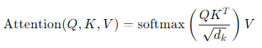

* **Query**: The vector representing the current word or token.
* **Key**: A representation of the tokens in the sequence that are being attended to.
* **Value**: The actual data associated with the tokens being attended to.
* The scaling factor **‘root(dk)’** prevents large dot-products from pushing the SoftMax into regions with small gradients, improving training stability.

**Multi-Headed Attention:**

Instead of performing a single attention function, the Transformer uses **multi-head attention**. The input is projected into multiple smaller subspaces, and attention is applied in parallel. The results are concatenated and projected to the final output. This allows the model to capture information from different subspaces and attend to different positions simultaneously.

1. **Position-Wise Feed-Forward Networks:**

Each layer of the encoder and decoder contains a **feed-forward network (FFN)** that applies two linear transformations with ReLU activation in between. This network operates independently on each position in the sequence.



Despite being simple, this layer helps the model learn complex transformations of the input.

1. **Positional Encoding:**

Since the Transformer does not have recurrence or convolutions, it lacks a way to incorporate the **order** of tokens in a sequence. To address this, the model adds **positional encodings** to the input embeddings. These encodings use sine and cosine functions of different frequencies to inject information about token positions into the model:

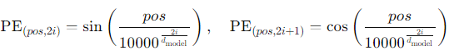

This allows the model to capture positional relationships between tokens without relying on recurrence.

1. **Why Self-Attention:**

The authors compared self-attention to traditional **RNNs** and **CNNs** in terms of computational complexity, parallelization, and path length between dependencies:

1. **Computational Complexity:** Self-attention operates with complexity **‘O(n^2d)’** where **‘n’** is the sequence length and **‘d’** is the dimension of the embeddings. This is more efficient than recurrent models, which operate with complexity **‘O(n^2d)’**.
2. **Parallelization:** Self-attention allows for **full parallelization** because it processes the entire sequence simultaneously. RNNs, by contrast, process tokens sequentially, limiting the ability to parallelize.
3. **Long-Range Dependencies:** In self-attention, the maximum path length between any two tokens is 1, since all tokens attend to each other directly. In RNNs, the path length is proportional to the sequence length, making it harder to capture long-range dependencies. CNNs require many layers to achieve this, but self-attention achieves it in a single step.
4. **Results and Performance:**

The Transformer model was evaluated on two machine translation tasks: **English-to-German** and **English-to-French**. It achieved state-of-the-art performance, surpassing previous models (including those with RNNs and CNNs). Key results include.

* **English-to-German Translation**: The Transformer achieved a **BLEU score of 28.4**, outperforming all previous models, including ensembles.
* **English-to-French Translation**: The model set a new state-of-the-art **BLEU score of 41.8.**

The Transformer required significantly less training time compared to previous architectures, achieving these results in just **12 hours on 8 GPUs** for the base model.

1. **Importance and Impact:**

The **Transformer** represents a shift away from traditional sequence models like RNNs and CNNs, introducing a new paradigm based entirely on attention. Its benefits include:

* **Parallelization**: By removing recurrence, the Transformer can process sequences much faster, making it highly efficient for training large models.
* **Handling Long Sequences**: Self-attention allows the model to capture long-range dependencies in a single step, making it better at handling long sentences and complex relationships.
* **Scalability**: The Transformer is highly scalable, allowing for the training of larger models that achieve superior performance on a variety of tasks.

This model laid the groundwork for subsequent advancements in NLP, most notably **BERT**, **GPT**, and other Transformer-based models that now dominate the field of natural language processing.

* **Key Components of the Transformer Model:**

1. **Self-Attention Mechanism:**

The core innovation of the Transformer is the **self-attention mechanism**, **which allows each token in a sequence to attend to all other tokens**, making it possible to capture long-range dependencies.

* **Self-attention:** computes a representation of a sequence by focusing on different parts of the sequence. For each word in the input, the model calculates how much "**attention**" to give to each other word in the sequence.
* **Scaled Dot-Product Attention**: Given queries **‘Q’**, keys **‘K’**, and values **‘V’**, self-attention is computed as:



**Where,**

* **Q** (query) represents the word being processed.
* **K** (key) represents the words being attended to.
* **V** (value) is the data associated with each key.
* **dk** is the dimensionality of the keys, and the scaling factor **‘root(dk)’** prevents extremely large values from pushing the SoftMax into regions with small gradients.

1. **Multi-Headed Attention:**

To further improve the model’s ability to focus on different parts of the input sequence, the Transformer employs **multi-head attention**. Instead of performing a single attention function, the input is projected into multiple smaller spaces, and several attention mechanisms (called **heads**) are applied in parallel. This allows the model to attend to different aspects of the input at the same time.

The outputs from these heads are then concatenated and projected back into the original space. The advantage is that the model can jointly attend to information from different parts of the sequence more effectively.



Each head computes attention independently:

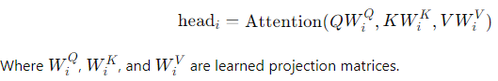

1. **Positional Encoding:**

Since the Transformer lacks the inherent sequential structure of RNNs, it uses **positional encodings** to inject information about the position of tokens in the sequence. Without positional information, the model would treat all tokens as if they were unordered, which is problematic for tasks like translation, where word order is critical.

The paper introduces **sinusoidal positional encodings**, where the position of each token is represented by a combination of sine and cosine functions:

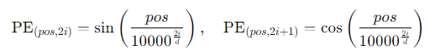

These encodings are added to the token embeddings to retain positional information. The choice of sine and cosine ensures that the model can generalize to sequences longer than those seen during training.

1. **Feed-Forward Networks (FFN):**

Each layer of the Transformer’s encoder and decoder also contains a **feed-forward neural network (FFN)**. This is a simple fully-connected network that is applied to each position in the sequence independently.

The **FFN** is composed of two linear transformations with a **ReLU activation** between them:



The purpose of the **FFN** **is to introduce non-linearities and learn complex transformations for each token in the sequence**.

1. **Residual Connections and Layer Normalization:**

To facilitate gradient flow and improve training stability, **residual connections** are added around each sub-layer in both the encoder and decoder. This means the input to a sub-layer is added to its output:



Where Sublayer(x) represents either the multi-head attention or feed-forward sub-layer. After applying the residual connection, the result is normalized using **layer normalization.**

* **Why Transformer is Important:**

The Transformer model revolutionized NLP and sequence-based tasks due to its key advantages:

1. **Parallelization:** By removing recurrence, the Transformer can process sequences in parallel, drastically reducing training times and allowing it to scale too much larger datasets.
2. **Handling Long-Range Dependencies:** Self-attention allows the model to capture dependencies between distant tokens in a single step, making it far more effective at handling long sequences than RNNs or CNNs, which require multiple layers or recurrent steps to do so.
3. **Scalability:** The Transformer’s efficiency and ability to parallelize operations made it highly scalable, allowing researchers to train massive models like **BERT** and **GPT** on enormous datasets, leading to dramatic improvements in tasks like text generation, question answering, and language understanding.
4. **Simpler Architecture:** The Transformer’s architecture is simpler than RNNs and CNNs, relying only on self-attention and feed-forward networks. This simplicity, combined with its effectiveness, made it a popular choice for a wide range of sequence transduction tasks.

* **Impact and Legacy:**

The **Transformer** has had a profound impact on machine learning, particularly in the field of natural language processing. It became the foundation for subsequent models such as:

* **BERT (Bidirectional Encoder Representations from Transformers)**: A Transformer-based model for language understanding tasks like text classification and question answering.
* **GPT (Generative Pretrained Transformer)**: Used for text generation, GPT-3 is one of the most well-known Transformer models and is capable of generating human-like text.
* **T5, RoBERTa, XLNet**, and many other models are also built upon the Transformer architecture.

The paper **"Attention Is All You Need"** introduced a new era of NLP, pushing the boundaries of what machine learning models can achieve in text-based tasks.

* **Self-Attention:**

Self-attention is a mechanism that allows a model to relate different parts of a single input sequence to each other when processing that sequence. This mechanism helps capture dependencies between tokens in a sequence, regardless of their distance from one another, and is a core component of the **Transformer model.**

* **Why is it called ‘Self’?**

The term "self-attention" is used because, instead of attending to a different input sequence (as in the traditional encoder-decoder architecture), the model is **attending to itself**. Each token in the sequence computes its attention score with every other token in the sequence, including itself.

* **How Self-Attention Works:**

Let’s break it down with an example:

**Example: Processing a Sentence**

Suppose we have a sentence for translation: ‘**The cat is on the mat.’**

**The self-attention mechanism would allow each word in the sentence to ‘attend’ to all the other words,** **computing a weighted relevance score for each pair of words in the sequence**. This means that when processing the word **‘cat’**, **the model can look at the entire sentence and determine which words are important for understanding** **‘cat’** **in context**.

**Steps of Self-Attention:**

1. **Create Queries, Keys, and Values:** For each word, the model creates three vectors:

* **Query (Q):** A vector that represents the word you're focusing on.
* **Keys (K):** A vector for each word in the sequence (used to compare with the query).
* **Values (V):** Another vector for each word, which holds the actual information you want to extract based on the attention score.

1. **Calculate Attention Scores:** The attention score between each word pair is computed using the **dot product** between the query of one word and the key of another word, followed by a scaling factor (to prevent overly large values) and a **SoftMax** to normalize the scores into probabilities:



The output is a weighted sum of the values, where the weights come from the attention scores.

1. **Context Representation: The final result is a** **‘context’** **vector for each word, which is a combination of the other words in the sequence**, weighted by their importance to the current word. This allows the model to better understand the meaning of each word in the context of the entire sentence.

* **Why Self-Attention is Important:**
* **It helps capture long-range dependencies between words**.
* It’s **parallelizable**: Unlike RNNs, which process inputs sequentially, self-attention can process all tokens in parallel, speeding up training.

* **Multi-Headed Attention:**

**Multi-headed attention** is an extension of self-attention that allows the model to attend to different parts of the sequence simultaneously in **multiple ways**. Instead of performing a single attention calculation, the model splits the input into multiple smaller subspaces, applies attention independently to each one, and then concatenates the results.

* **Why Multi-Headed?**

It allows the model to **capture different relationships** between words. For example, one attention head might focus on the syntactic structure, while another focuses on the semantic meaning.

* **Example:**

Consider the sentence **“The cat sat on the mat.”**

* One head might focus on **“The cat”** as a subject-predicate relationship.
* Another head might focus on **“sat on”** as a prepositional phrase.
* A third head might focus on **“on the mat”** to understand the location.

Each head computes attention independently, and the final result is the concatenation of all the head outputs.

* **Multi-Head Attention Formula:**

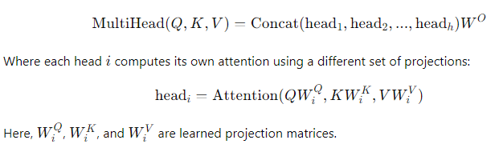

* **Masked Self-Attention:**

**Masked self-attention** is used in tasks where the model generates sequences, such as in language generation. The mask prevents the model from looking ahead at future tokens in the sequence while making predictions, ensuring the model generates one token at a time in an autoregressive manner.

* **Why Masked?**

When generating text, you want to ensure that each token in the sequence only has access to the tokens that have already been generated, not the future ones. This prevents the model from **‘cheating’** by looking at future words.

* **Example:**

If the input sentence is **“The cat sat on the mat.”** and the model is predicting the next word:

* While predicting the word **“sat”**, the model should not have access to **“on”** or **“the mat”**.
* The **mask** prevents the model from seeing future tokens during training, ensuring that predictions are made one step at a time.

* **Cross-Attention:**

The **Cross-Attention mechanism** is a variant of the attention mechanism used in transformer architectures. While **self-attention** allows the model to focus on different parts of the same input sequence (e.g., encoder or decoder's inputs), **cross-attention** allows the model to **focus on an external sequence**, such as the output of an encoder in **encoder-decoder architecture**.

* **Example:**

In machine translation, suppose we’re translating the sentence **“The cat is on the mat.”** from English to French:

* The encoder processes the English sentence and generates a sequence of hidden states.
* The decoder generates the French translation. At each step, **cross-attention** allows the decoder to focus on specific parts of the encoded English sentence (such as focusing on the word **“cat”** when generating **“chat”** in French).
* **How Cross-Attention Works:**

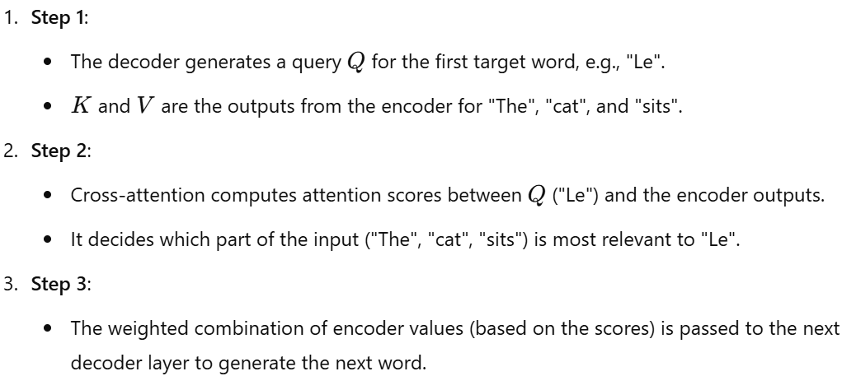

The **“Attention Is All You Need”** paper introduced the Transformer, a highly efficient and scalable architecture for sequence-to-sequence tasks, which has become the standard model in NLP. The key innovation, **self-attention**, replaced recurrence and convolution with parallelizable operations that can handle long-range dependencies efficiently. The Transformer has since become the backbone of many state-of-the-art models, revolutionizing the way we approach tasks such as machine translation, text generation, and language understanding.

**Difference between Attention, Self-Attention, Multi-Headed Attention:**

These three concepts are related to how models focus on different parts of input data when processing sequences. Let’s explore each of them with definitions and examples.

* **Attention:**

**Attention** is a mechanism that allows models to **focus on different parts of an input sequence** when producing an output. It assigns **weights** to different input elements, indicating their importance for generating each output element. Attention mechanisms are often used in **sequence-to-sequence tasks**, such as machine translation, **where it’s necessary to map input sequences to output sequences** of different lengths.

* **Example:**

**Machine Translation**: Suppose you are translating the English sentence **“The cat is on the mat.”** into French **“Le chat est sur le tapis.”**

* When generating the French word **“chat”**, the model might assign a higher weight to the English word **“cat”** because it is more relevant at that step.
* Similarly, while translating **“mat”** to **“tapis”**, the model will focus more on the word **“mat”** in the input sentence.

In this case, the attention mechanism allows the model to dynamically focus on different words in the input sequence when producing each word in the output.

* **Self-Attention:**

**Self-Attention** is a type of attention mechanism where a sequence **attends to itself**. In self-attention, each word (or token) in the input sequence computes its relationship with all other words in the sequence (**syntactic** **or semantic**), allowing the model to **capture dependencies between words, regardless of their positions**. Self-attention is widely used in **Transformer models.**

* **Example:**

**Sentence Understanding**: For the sentence **“The cat sat on the mat.”**, self-attention helps the model determine how each word relates to the others.

* When processing **“cat”**, the model attends to related words like **“sat”** and **“mat”**, understanding that **“cat”** is the subject that **“sat”** on something.
* Each word is assigned a weight, indicating its relevance to other words in the sentence. This helps capture the context more effectively than relying only on word order.

Self-attention enables the model to **consider the entire sequence simultaneously**, making it suitable for tasks where long-range dependencies are important.

* **Multi-Headed Attention:**

**Multi-Headed Attention** extends self-attention by using **multiple attention heads** to capture different aspects of relationships between (**syntactic**, **semantic**, **positional**, **overall** **context**) words. Each attention head works independently to learn different **subspaces of the data**, and the results are combined to form a more comprehensive representation.

* **Example:**

**Understanding Different Relationships**: In the sentence **“The cat sat on the mat.”**, different attention heads can focus on different types of relationships:

* **Head 1** might focus on **the subject-verb relationship** (cat **→** sat).
* **Head 2** might capture **prepositional phrases** (on **→** mat).
* **Head 3** might consider **the overall context**, understanding that the entire phrase describes the location of the cat.

Each head captures different patterns, and their outputs are **concatenated and linearly transformed** to get the final output. This enables the model to attend to multiple aspects of the input sequence simultaneously, enhancing its ability to understand complex relationships.

**Key Components of Transformer Architecture:**

The Transformer architecture is built on several core components that allow it to process sequences of data efficiently. Let's dive into each of the following concepts in detail:

1. **Feed-Forward Neural Network (FFN):**

In the Transformer architecture, the **Feed-Forward Neural Network (FFN)** is used after the multi-head attention mechanism in both the encoder and decoder layers. It **introduces non-linearity** into the model and transforms the input features for better representation.

* **How It Works:**
* The FFN is applied **independently to each position** in the sequence. It consists of two linear transformations with a **ReLU activation** function in between:

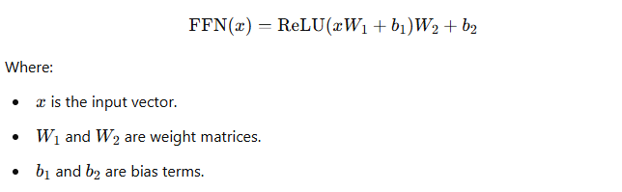

* The same set of weights is used for each position, making it a **position-wise FFN.**
* **Purpose:**
* To introduce **non-linear transformations**, which help the model learn complex patterns in the data.
* Helps capture **relationships and dependencies** between different features in the transformed space.

1. **Positional Encoding:**

Since the Transformer architecture **does not use recurrence or convolution**, it lacks a mechanism to capture the **order of words** in a sequence. **Positional Encoding** is introduced to inject information about the positions of tokens in a sequence.

* **How It Works:**
* Positional encodings are **added to the input embeddings** before they are fed into the encoder. The positional encoding vector has the same dimension as the input embeddings.
* The positional encoding uses a combination of **sine and cosine functions** to represent different positions in the sequence:

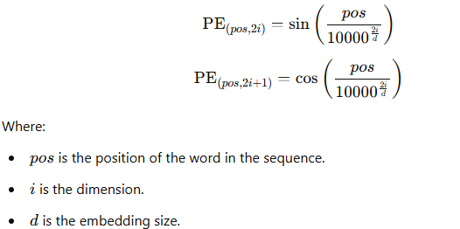

* **Purpose:**
* Allows the model to **distinguish between different positions in the sequence**.
* Helps the Transformer understand the **order of words**, which is crucial for tasks like language modelling and translation.

1. **Layer Normalization in Transformer:**

**Layer Normalization** is a normalization technique used to **stabilize the training process** and **improve convergence by normalizing the input** across the features for each data point.

* **How It Works:**
* In a Transformer layer, normalization is applied **before the feed-forward neural network and multi-head attention sub-layers.**
* For a given input vector x-bar layer normalization is computed as:

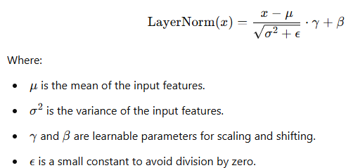

* **Purpose:**
* Helps in **stabilizing the training process** by reducing the internal covariate shift.
* Improves **gradient flow** through the network and enables deeper networks to be trained.

1. **Decoder Masked Attention:**

In the decoder of the Transformer, there is a mechanism called **Masked Self-Attention**, which prevents the model from attending to **future tokens** in the sequence during training.

* **How It Works:**
* In **masked self-attention**, an upper triangular mask is applied to the attention matrix, setting the weights of future positions to **negative infinity.**
* This ensures that, **when predicting the next token in the sequence, the model can only attend to the current and previous tokens not the future tokens**.
* **Purpose:**
* Ensures the model generates the output **auto regressively**, meaning one token at a time.
* Prevents the model from **“cheating”** by looking at future tokens, thereby maintaining causality.

1. **Encoder Decoder Multi-Headed Attention:**

The **Multi-Head Attention** mechanism is used in both the encoder and decoder to allow the model to focus on different parts of the input sequence or previously generated tokens simultaneously.

* **How It Works:**
* **Multi-Head Attention** splits the input into multiple **heads**, applies self-attention independently to each head, and then **concatenates** the results:

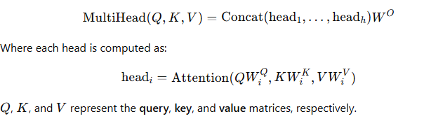

* **Purpose in Encoder:**
* **Self-Attention in Encoder**: Each word in the input attends to every other word, helping the model understand relationships within the input sequence.
* **Purpose in Decoder:**
* **Masked Self-Attention in Decoder**: Allows the model to attend/focus only to previous words when generating the next token.
* **Encoder-Decoder Attention**: The decoder uses multi-head attention to attend to the encoder’s output, helping it incorporate information from the input sequence when generating output tokens.

1. **Liner and Softmax layer:**

After the **multi-head attention** and **feed-forward neural network**, the output goes through a **linear transformation** followed by a **Softmax function** to generate probabilities for the target vocabulary.

* **How It Works:**
* **Linear Layer**: Projects the final output vector to a vector of size equal to the vocabulary size. This step converts the hidden states into logits for each possible token in the vocabulary.



* **Softmax Layer**: Applies the Softmax function to convert the logits into a probability distribution over the vocabulary.

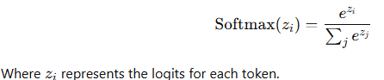

* **Purpose:**
* Converts the hidden representations into a **probability distribution**, allowing the model to predict the next word in the sequence.

**Contextual Embeddings:**

* **Contextual Embeddings: An Overview**

**Contextual embeddings** are representations of words or phrases that take into account the **context** in which they appear. Unlike traditional word embeddings (such as **Word2Vec** or **GloVe**), which **generate a single static vector** **representation** for each word regardless of its usage, contextual embeddings produce different vectors for the same word depending on the surrounding words, capturing the nuances of meaning based on context.

* **Example of Contextual Embeddings:**

Consider the word **“bank”** in two different sentences:

1. **“He sat on the river bank.”**
2. **“She went to the bank to deposit money.”**

**In these examples:**

* In the first sentence, **“bank”** refers to the **side of a river.**
* In the second sentence, **“bank”** refers to a **financial institution.**

A **contextual embedding** model, like **BERT** or **GPT**, would generate different vector representations for **“bank”** in each sentence because the surrounding context indicates different meanings. This is in contrast to traditional word embeddings, where **“bank”** would have the same vector representation in both cases.

* **How Contextual Embeddings Works:**

Contextual embedding models use **Transformer-based architectures** that rely on **self-attention mechanisms** to understand the relationship between each word and its surrounding context within a sentence. These models process entire sentences at once, capturing the meaning of each word as influenced by other words in the sequence.

**Architecture of Embedding Models: Explanation using an Example (e.g., text-embedding-3-large):**

An embedding model like **OpenAI's text-embedding-3-large** is designed to generate high-quality embeddings for various natural language processing (NLP) tasks.

* **Let's explain the architecture typically found in such models:**

1. **Input Layer:**

* The input to the model is a sequence of tokens, which are typically words or subwords (e.g., "bank", "river", etc.). The input text is tokenized using a **tokenizer.**
* Each token is converted into a corresponding **input embedding**, which includes **word embeddings**, **positional encodings**, and **token type embeddings** (if used).

1. **Transformer Layers (Contextual Embedding Generation):**

* The core of the embedding model consists of multiple layers of **Transformers**. Each layer includes **multi-head self-attention** and **feed-forward neural networks:**
  + **Multi-Head Self-Attention**: Allows the model to focus on different parts of the input sequence simultaneously, capturing dependencies between words regardless of their positions.
  + **Feed-Forward Neural Network (FFN)**: Add non-linearity to the model, helping it learn complex patterns in the data.
  + **Residual Connections and Layer Normalization**: These help stabilize training and improve gradient flow.
* The model generates **contextual embeddings** at each layer, where each word's representation is influenced by its surrounding context. The deeper the layer, the more refined the contextual information becomes.

1. **Output Layer (Embedding Extraction):**

* The final embeddings are extracted from the last layer of the Transformer. Depending on the task, the output could be:
  + **Token-level embeddings**: Representing each word or subwords in the sequence, useful for tasks like **named entity recognition.**
  + **Token-level embeddings**: Representing each word or subwords in the sequence, useful for tasks like **named entity recognition.**

1. **Training the Embedding Model:**

* Embedding models like **text-embedding-3-large** are trained on large corpora using tasks such as **masked language modelling** (e.g., predicting masked words) or **next sentence prediction**. This helps the model learn meaningful relationships and generate high-quality embeddings.

**Difference between Language Model and Large Language Model:**

**Language Model (LM)** and **Large Language Model (LLM)** are terms often used interchangeably, but there are some key differences between them, particularly in terms of **scale**, **capabilities**, and **architecture**. Let's explore these differences in detail.

1. **Language Model (LM):**

A **Language Model (LM)** is a model that is trained to understand and generate human language. **The primary goal of a language model is to predict the next word in a sequence or to estimate the probability of a given words sequence.** Language models are used in various natural language processing (NLP) tasks such as **speech recognition**, **text generation**, **machine translation**, and **sentiment analysis.**

* **Common Characteristics of Language Model:**
* **Trained on Limited Datasets:** Traditional language models are trained on smaller or more specific datasets.
* **Smaller Parameter Size:** They usually have a smaller number of parameters, which limits their ability to understand complex language patterns.
* **Architecture:** Traditional language models can use different architectures like **n-grams**, **Recurrent Neural Networks (RNNs)**, **Long Short-Term Memory (LSTM)** networks, or **Transformers.**

Not necessarily. Early language models used **n-grams**, **RNNs**, or **LSTMs**, which do not follow the Transformer architecture. However, many recent language models do use the Transformer architecture due to its superior performance.

1. **Large Language Model (LLM):**

A **Large Language Model (LLM)** is an advanced type of language model that is trained on **massive datasets** with **billions or even trillions of parameters**. LLMs leverage the **Transformer architecture** and are capable of understanding and generating human-like text in more sophisticated ways.

* **Common Characteristics of Large Language Model:**
* **Trained on Massive Datasets:** LLMs are trained on large corpora of text, including books, articles, websites, and other textual sources.
* **Large Number of Parameters:** These models have hundreds of millions to trillions of parameters, enabling them to understand complex language patterns, perform reasoning, and generate coherent text.
* **Use of Transformer Architecture:** LLMs are typically based on the **Transformer architecture**, which allows for efficient parallel processing and capturing of long-range dependencies in text.
* **Pre-Training and Fine-Tuning:** LLMs are often **pre-trained** on large datasets in an unsupervised manner and then **fine-tuned** on specific tasks for better performance.
* **Scalability:** LLMs consist of **many layers (12, 24, or even 96+ layers)** in the Transformer architecture, enabling them to capture deep semantic relationships. Use **large embedding sizes** and **multiple attention heads**, increasing their capacity to understand language nuances.

Yes, they are almost exclusively based on the **Transformer architecture**. The ability to **scale with large datasets**, **handle long sequences**, and **perform parallel processing** has made Transformers the standard architecture for LLMs.

The main difference between **Language Models (LMs)** and **Large Language Models (LLMs)** lies in the scale and capabilities of the models. While LLMs are always built on the **Transformer architecture**, traditional LMs may use a variety of architectures such as **n-grams**, **RNNs**, or **LSTMs**. The advent of Transformers has significantly advanced the development of LLMs, allowing them to achieve state-of-the-art performance in many natural language processing tasks.